Brightness Preserving bi-histogram Equalization (BBHE)

In this method, in order to preserve the brightness of the images, the original image is divided into two parts and then histogram of each part is equalized separately. The mean of the intensity of the image is set as a separated point. The problem of this method is that the intensity is saturated.

Fm is the point that the histogram is devided into two parts. In figure below, the input and outpu of an example image is depected.

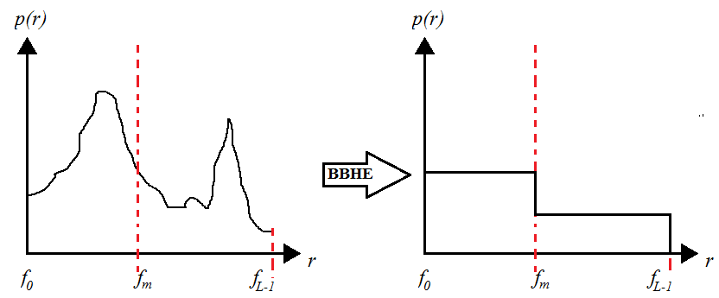

References:

[Won98]  
Wongsritong.K, Kittayaruasiriwat.K, Cheevasuvit.F, Dejhan.K (1998), "Contrast enhancement using multipeak histogram equalization with brightness preserving", IEEE Asia-Pacific Conference on Circuits and Systems, PP: 455 - 458.

[Kau11]  
Kaur.M, Kaur.J (2011), "Survey of contrast enhancement techniques based on histogram equalization", International Journal of Advanced Computer Science and Applications(IJACSA), Vol: 2, No: 7, PP: 137-141.